Angular Framework

Angular is a framework used to develop single page applications using HTML & Typescript.

Single Page Applications are applications that makes user to see everything in one page, it only loads part of the page instead of reloading the complete page whenever user interacts with the application.

Ex: Gmail, Facebook, GitHub, Angular.io, ...

Angular uses component to render the data, components are UI’s which can be independently built and reused in other components. They are build without knowing where it will be displayed

Ex: Facebook has Profile component, that can be reused in comments, likes, newsfeed and so on.

Angular uses HTML & Typescript to develop the application.

HTML: It is used display the content

Typescript: It is used to write logics in angular, like fetching the data from server and passing the data to the HTML, deciding what components to be loaded and so on.

Typescript is a super-set of Javascript, it is less error prone compare to javascript, Typescripts are compiled to javascript.

* Typescript more safe compare to javascript
* It supports all the features of Javascript, including the new features of Javascript (released by ES6 in 2015)
* ES means EcmaScript which is a standard or specification for Javascript, ES is not a programming language, however Javascript implements the ES standard

Softwares required for Angular application development

* Visual Studio Code - Editor
* Node.js - Runtime environment to run javascript code & also angular code
* Angular CLI - toolkit for angular applications

ES6 features:

There are few new features added that simplifies javascript coding

* let, const, class, constructor keywords
* template strings
* arrow functions
* rest & spread operators

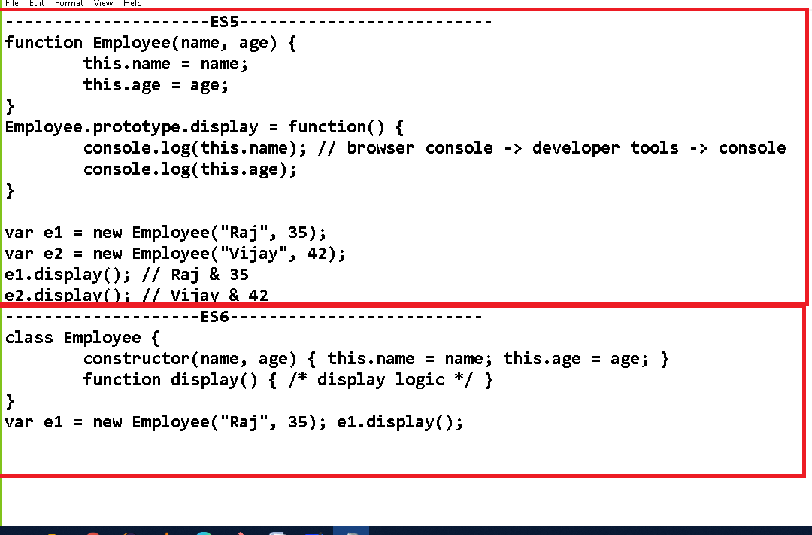

Creating function & object in ES5

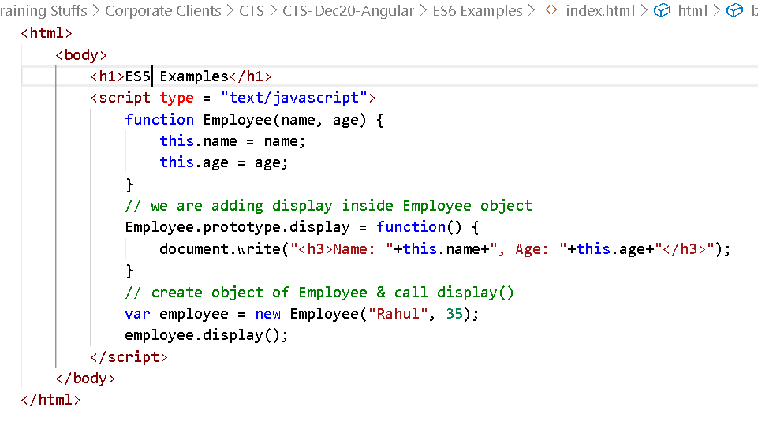

Output:

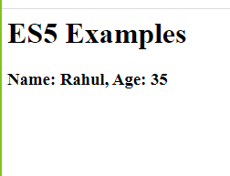

ES6 uses class & constructor keywords

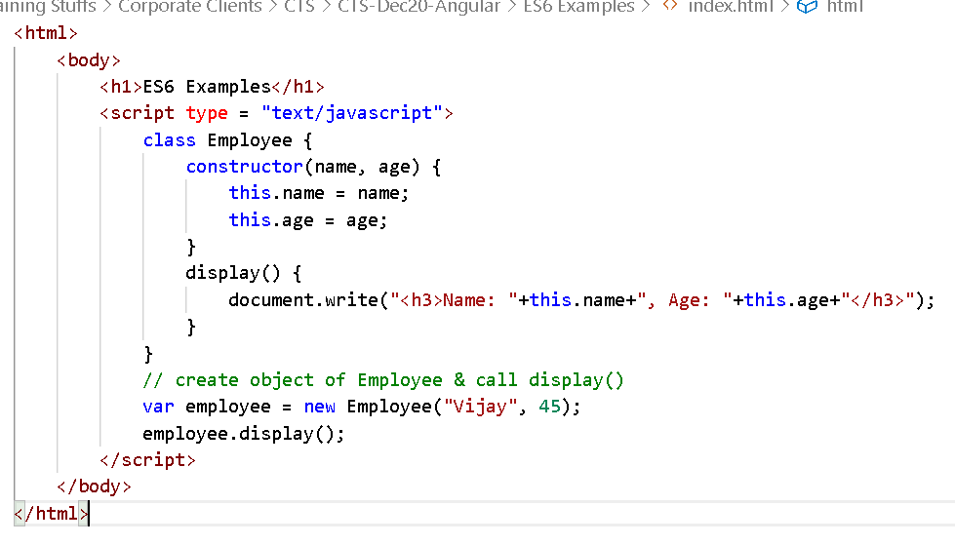

Output:

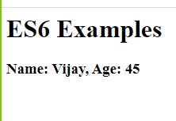

let, const keywords: these are used to create block scoped variables, because in javascript you were creating variable with ‘var’ which is not part of any scope.

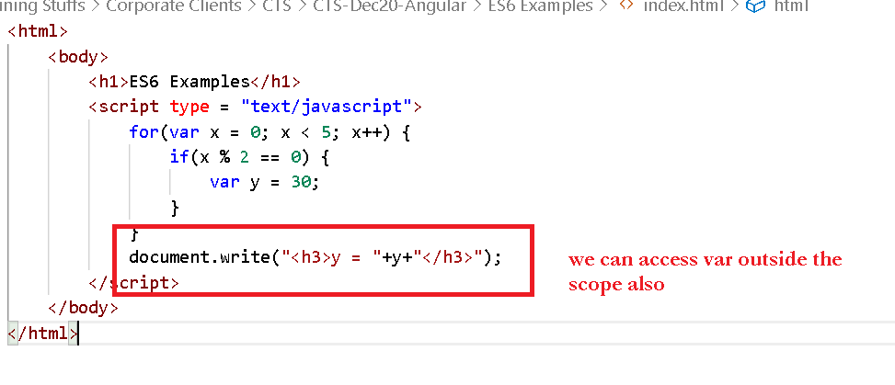

But with let & const you can create block scope variables

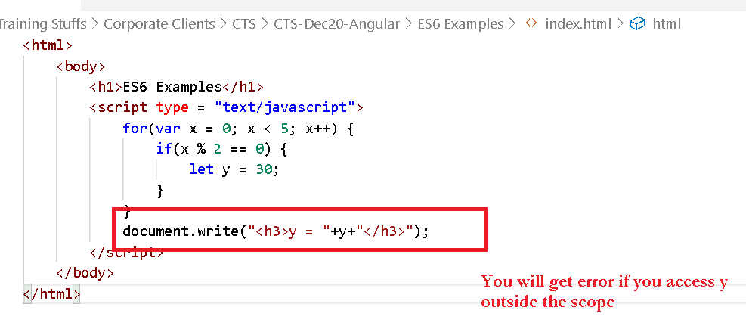

Template String

It allows you to create a string & access the data without breaking the strings using + operator.

Template strings uses a backtick(`) i.e., a quote below the Esc key.

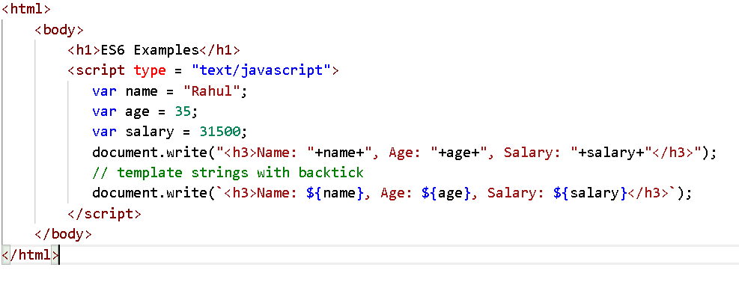

Output:

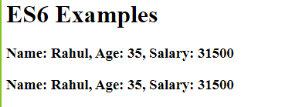

You can’t give line break without + in “ or ‘ quotes but you can give line break in ` without + operator

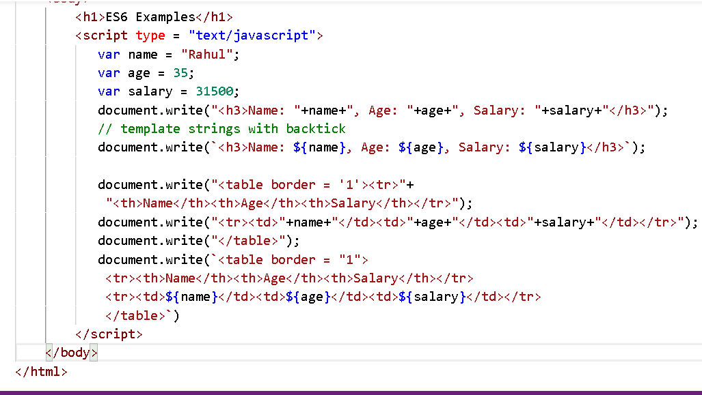

Output:

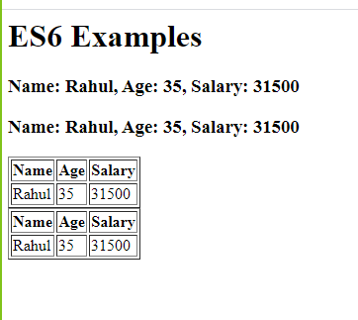

Arrow functions(=>):

These simplifies writing anonymous functions in javascript where they are having few lines of expressions.

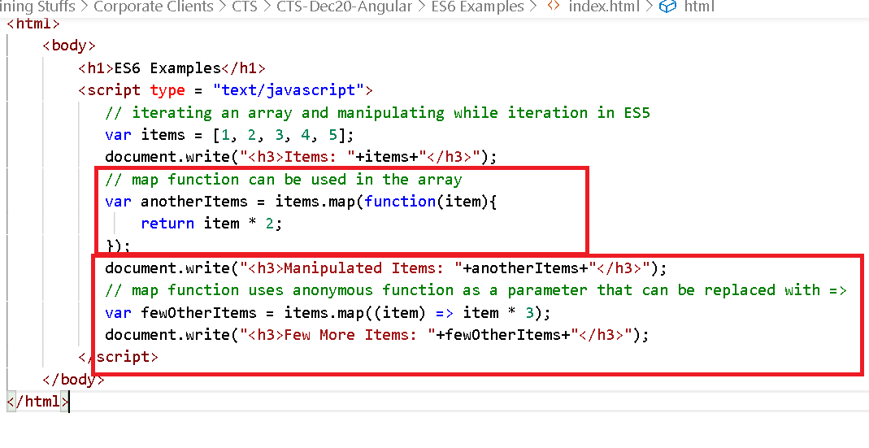

Output:

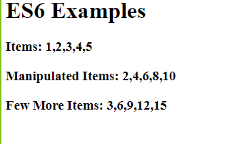

Rest & Spread operators

When a function doesn’t have an idea how many parameters are supplied by a caller you can have rest operator, and also when an input has to be spread across multiple parameters of a function you can use spread operator.

add(4, 3, 1, 2);  
add(4, 3);  
add();

Rest operator:

function add(...x) { .... }

The add function takes test parameter means can accept any number of parameters from 0 to many

function test(a, ...b) { ...}

The test function takes 1 parameter minimum followed by 0 or many parameters

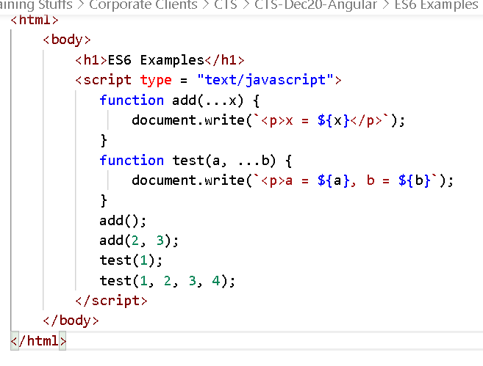

Output:

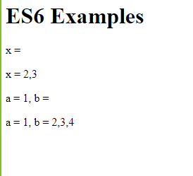

Spread operator

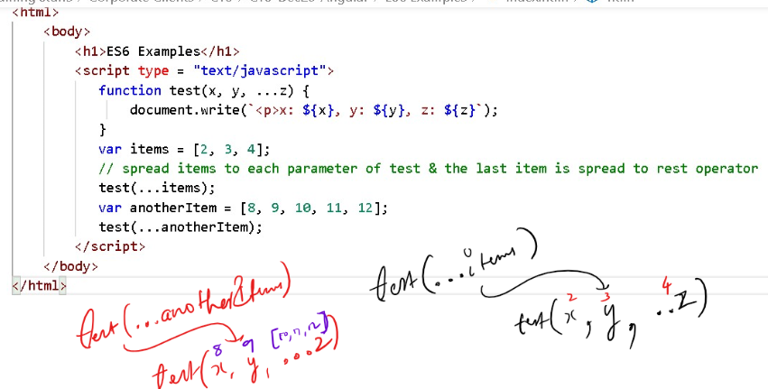

Output:

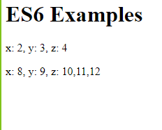

Typescript: It is a super-set of javascript, which supports all the javascript features including that it has some additional features

1. types for variables
2. return types for methods
3. short-cut initialization of constructor
4. import & exporting classes

Installing Angular Toolkit:

Command: *npm install -g @angular/cli*

How to create angular project

Command: *ng new my-first-app*

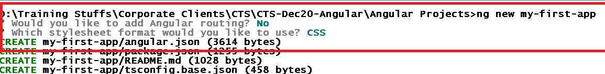

How to launch the application

Command: *ng serve*

How to add a component in another component

Angular gives you a command to generate the component, if you use this command it will automatically create 4 files

1. component class ts file
2. component html file
3. component css file
4. component spec file (testing purpose)

Updates the Application that component is created

Command: *ng generate component <<component-name>> (or)*

*ng g c component-name*

How to change the port

*ng serve --port=4201*

Angular Building Blocks:

These forms the angular application, the are:

1. Components: @Component({})
2. Modules: @NgModule({})
3. Pipes: |
4. Data-binding
5. Directives: ngFor, ngIf, ngSwitch
6. Services: @Injectable()
7. Routers: Navigations

Inline template

It is going to provide content in the @Component() decorator itself instead of a separate html file i.e, templateUrl.

@Component({  
 template: ‘content’  
})

hello.component.ts

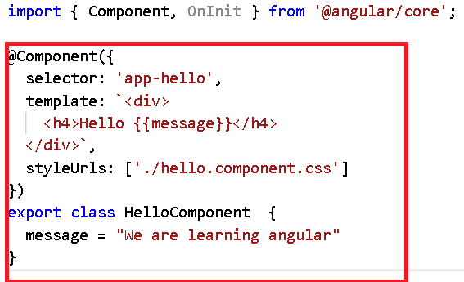

Add app-hello in root component

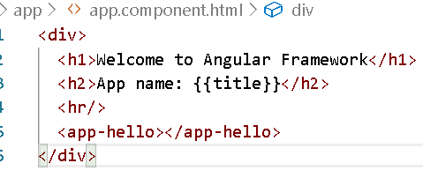

Output:

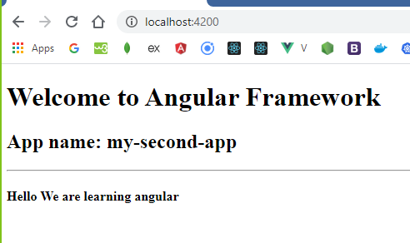

Different way of maintaining the data

Since you are using typescript, you can mention types

title : string = ‘string value’

employee : any = {“id”:1000, “name”:”Raj”}

employee : Employee = new Employee(1000, “Raj”);

employee : Employee[] = [array of employee objects]

hello/hello.ts

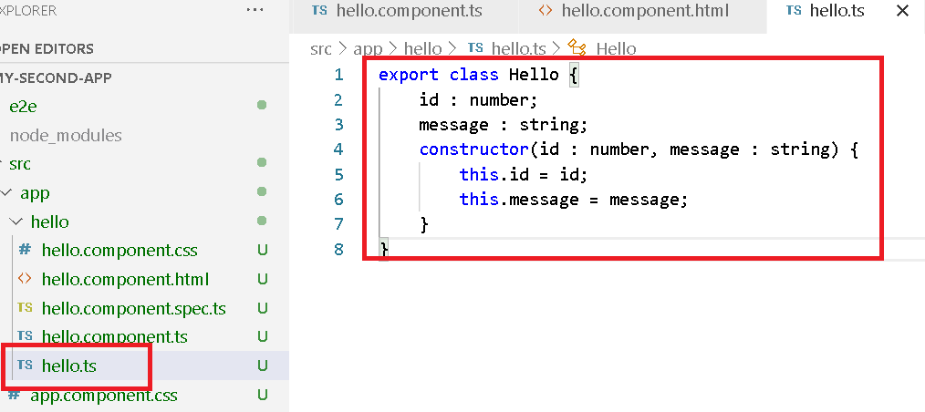

You should import Hello from hello.ts using

import { Hello } from ‘./hello’

hello/hello.component.ts

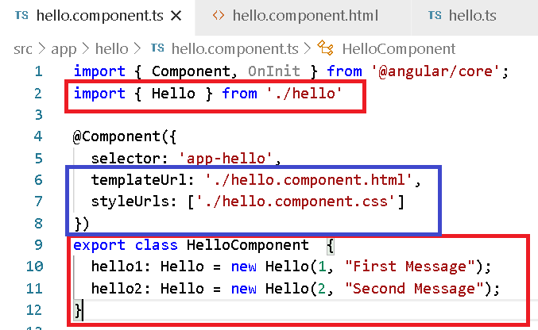

hello/hello.component.html

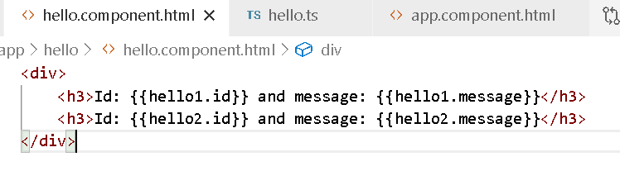

Output:

